- You will want an area to leave your Laptop plugged in and left alone for at least 45 minutes while your device resolved the update conflict.
- You will want to get to the Automatic Repair Windows 10 page to start this process. You may need to restart your device automatically start up this process. Please click on Advanced Options.
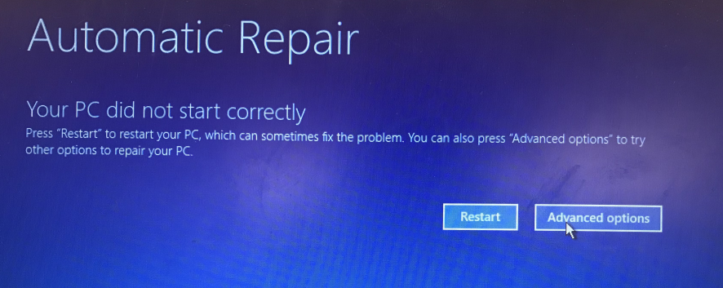

- Select “Troubleshoot”
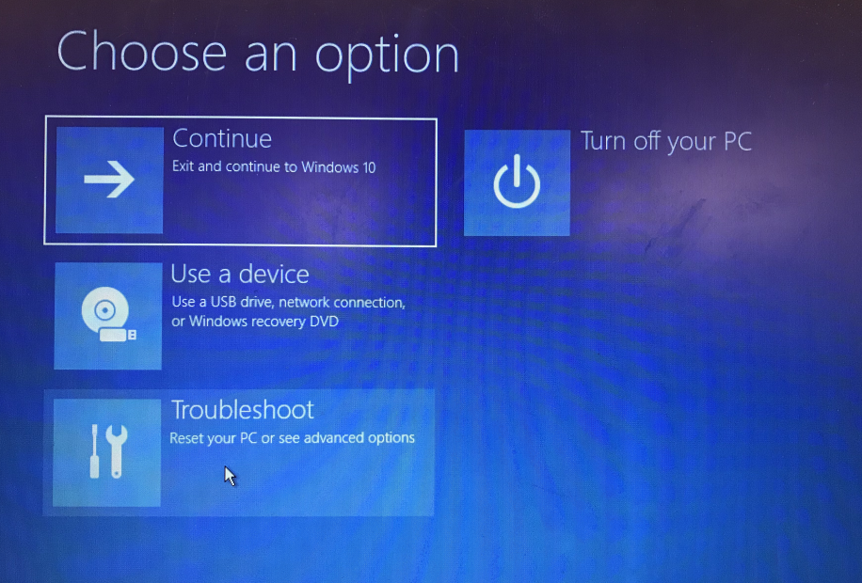

- Select “Reset this PC”
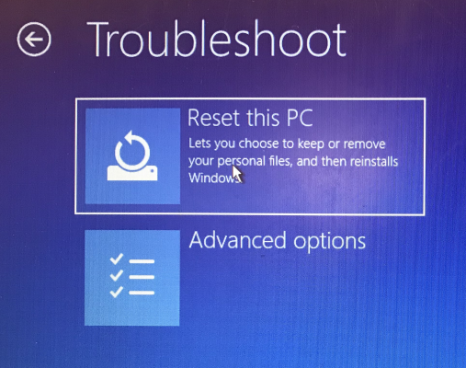

- Select “Keep my files”
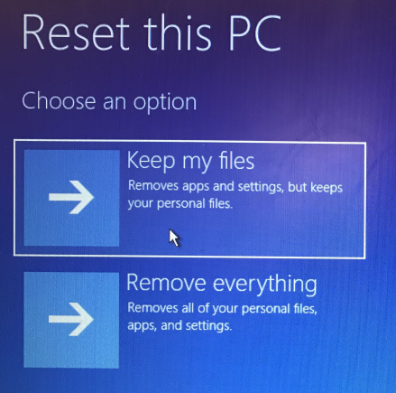
- Wait a moment for your device to compile your files
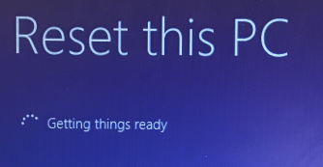

- Select “Reset”. This will keep your personal files however you will find that any specialized software will be removed from the device. Please do not turn off the device through this process and wait for the login screen to appear.
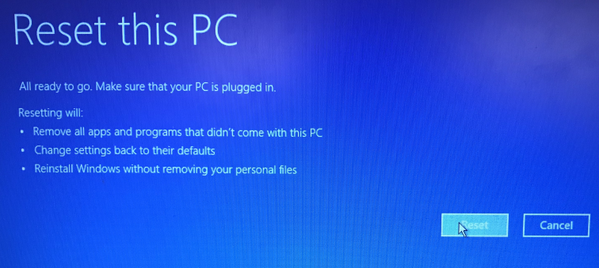
- After you sign into your device (You may need to use your full email address), please wait at least 15 minutes for your device to update policies.
If you have any further issues, please either submit a ticket in Tiger ID (https://login.northallegheny.org), email us at servicedesk@northallegheny.org, or call our Help Desk: # 412-369-5849.

